**Scenario 3: Customers should be able to transfer funds between their accounts.**

**CREATE OR REPLACE PROCEDURE TransferFunds (**

**from_account IN NUMBER,**

**to_account IN NUMBER,**

**amount IN NUMBER**

**) IS**

**from_balance NUMBER;**

**BEGIN**

**-- Lock and fetch source balance**

**SELECT balance INTO from_balance**

**FROM accounts**

**WHERE accountid = from_account**

**FOR UPDATE;**

**-- Check for sufficient balance**

**IF from_balance >= amount THEN**

**-- Deduct from source account**

**UPDATE accounts**

**SET balance = balance - amount**

**WHERE accountid = from_account;**

**-- Add to target account**

**UPDATE accounts**

**SET balance = balance + amount**

**WHERE accountid = to_account;**

**COMMIT;**

**ELSE**

**RAISE_APPLICATION_ERROR(-20001, 'Insufficient balance in source account');**

**END IF;**

**END;**

**/**

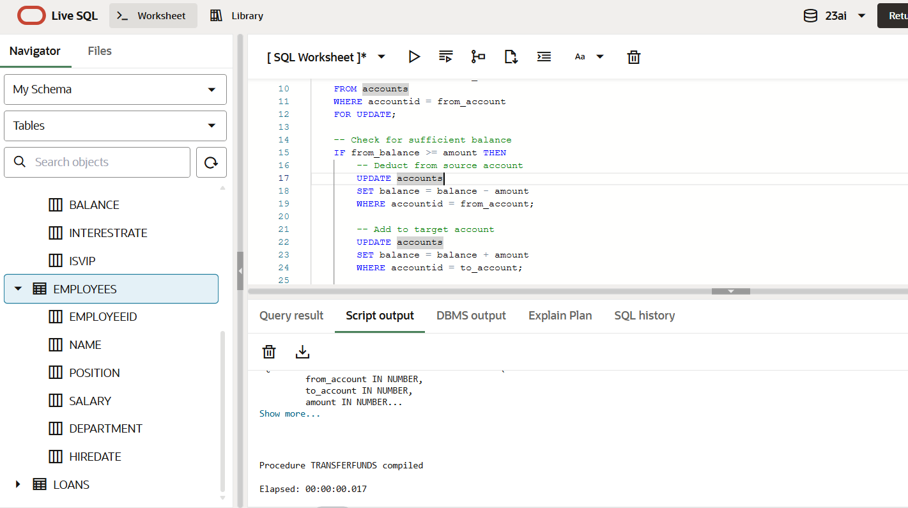

**OUTPUT**

